1. git init

Initializes the git repository



1. git add *

moves the changes done from the working directory to the staging area

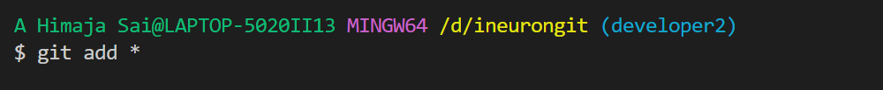

1. git status

It displays the changes that are staged for commit , the changes that are not staged, the files that are not tracked by git

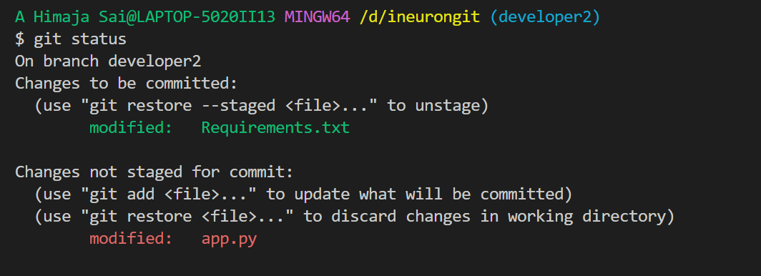

1. git branch <branch_name>

allows us to create a new branch, delete branch with out altering the content of the main branch

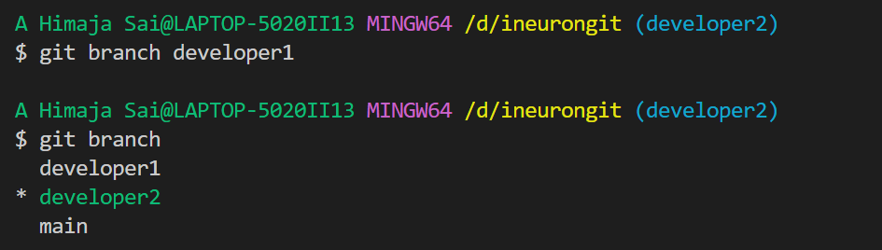

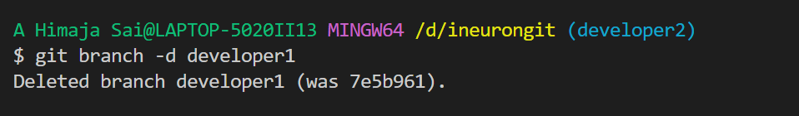

1. git checkout <branch_name>

it helps us to navigate between the existing branches

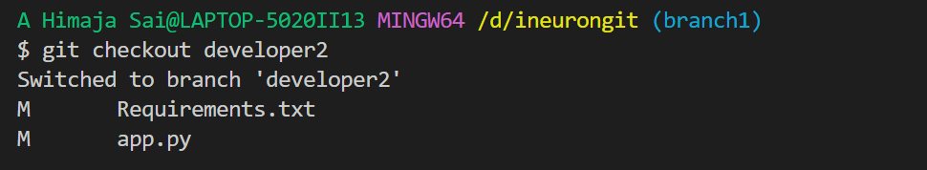

1. git checkout -b <branch_name>

it helps us simultaneously create a new branch and navigate to that created branch

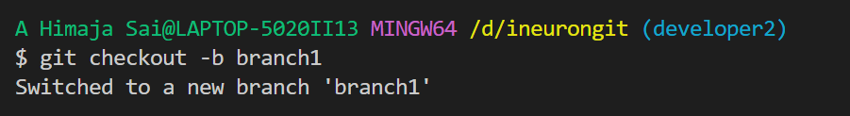

1. git commit

It helps commit the changes from staging area to git repository

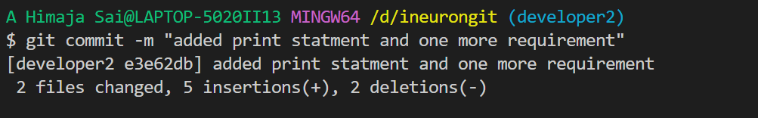

1. git clean -f

It helps remove the untracked files which we don’t to add to our git repository

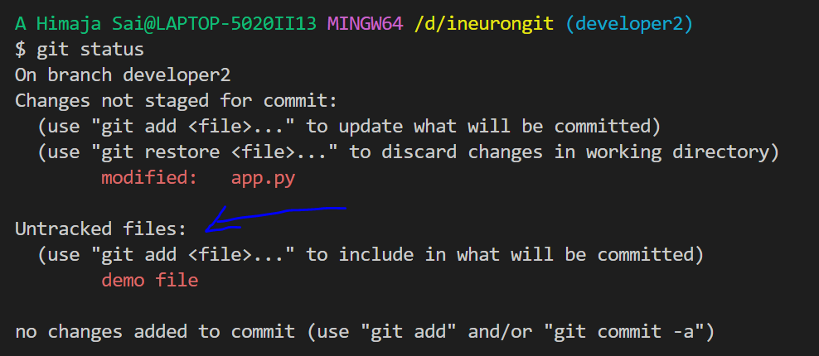

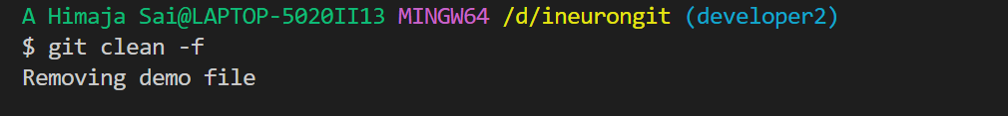

1. git log

It helps us to view the history of committed changes in our git repository

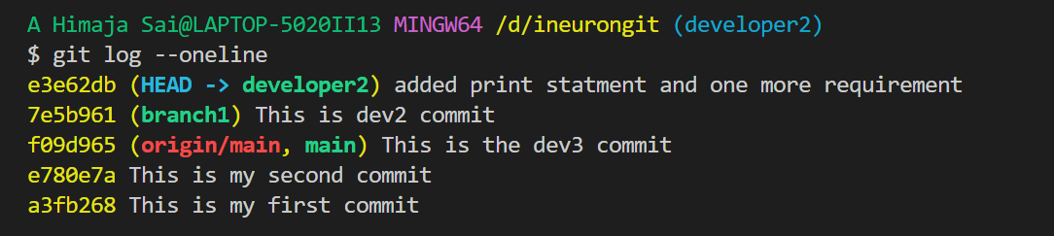

1. git clone

It is used to create a clone or copy of the existing repository in a new location

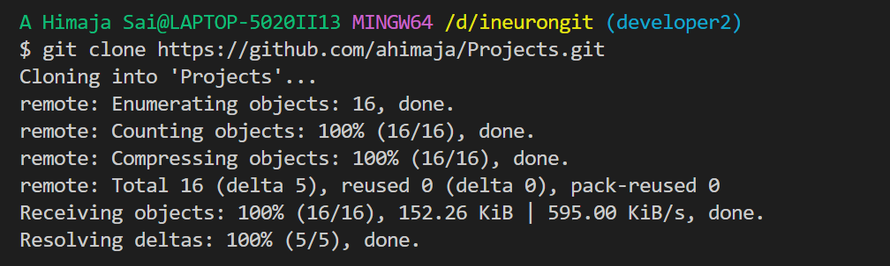

1. git diff

It helps us understand and compare the changes made(staged or unstaged) with respect to the last commit made

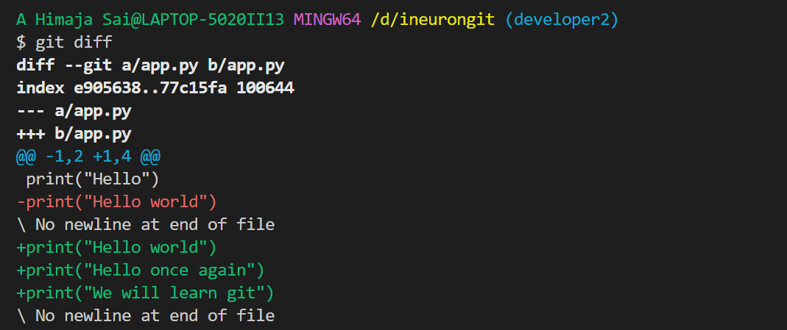

1. git diff <branch-1> <branch-2>

It helps us compare the differences between two branches

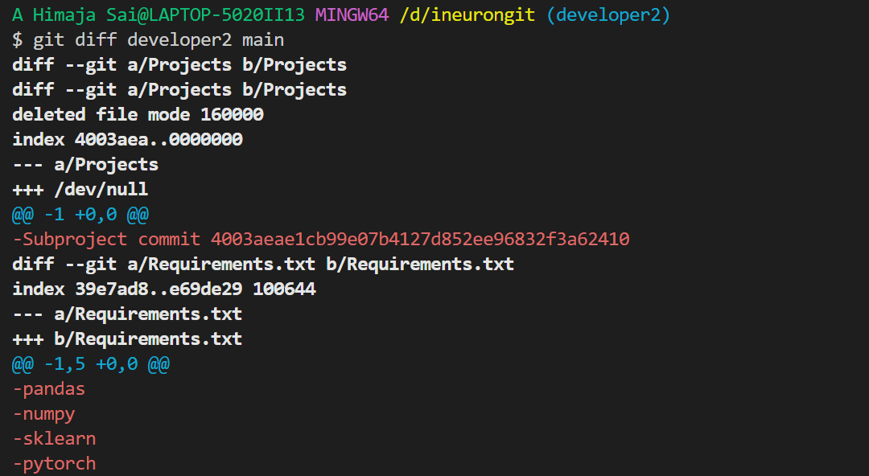

1. git reset <file_name>

It removes the file from the staging area, while preserving the contents of the file

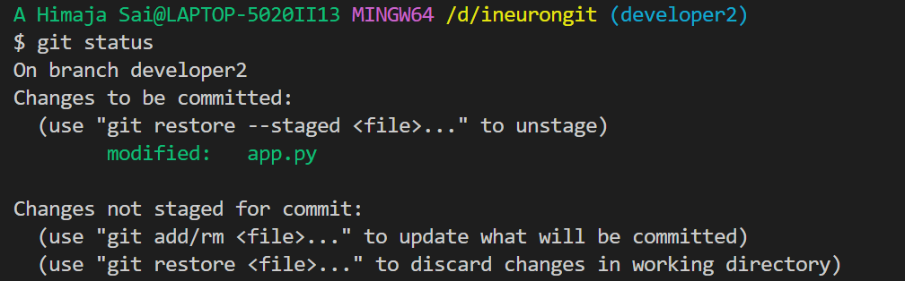

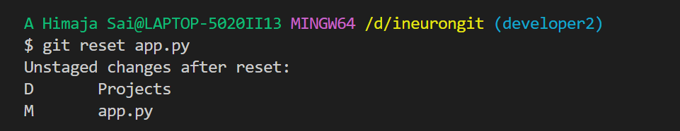

1. git tag

It is used for creating, deleting, modifying tags after the specified commit



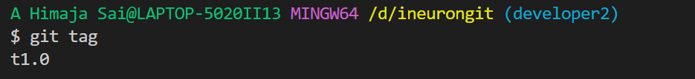

1. git merge

It is used to merge the changes made in the source branch to the target branch

